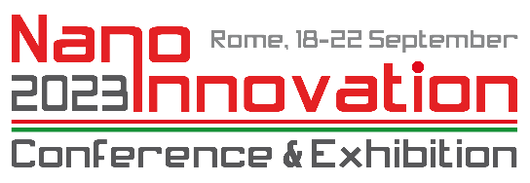

NANOINNOVATION 2023 ARTICLES APPLICATION FORM

Please return this form, properly signed, by email to
daniele.passeri@uniroma1.it adding in cc federica.scrofani@nanoinnovation.eu

(submission with December 9th, 2023 is warmly recommended)

Corresponding author details:

Name:
Surname:
Affiliation:
E-Mail address:

Article details:

Tentative TITLE:
Tentative ABSTRACT:
Tentative SUBMISSION DATE:

Tentative SPECIAL ISSUE/TOPIC/JOURNAL:
- Special Issue of Processes on “Innovation by nanotechnologies in manufacturing and environmental processes”

- Special Issue of Journal of Experimental and Theoretical Analyses (JETA) on “Advances in characterization techniques for material engineering and driving innovation”

- Topic on “Nanotechnology and nanomaterials in high-tech industries” with publication on one of these MDPI journals (please select):
  - Nanomaterials
  - Applied Science
  - Aerospace
  - Sensors

- Topic on “Nanotechnology and Nanomaterials in Food and Drugs” with publication on one of these MDPI journals (please select):
  - Foods
  - Biomedicines
  - Pharmaceutics

- Topic on “How Nanotechnology affects Cultural Heritage, Society, and Ethics” with publication on one of these MDPI journals (please select):
  - Heritage
  - Societies

